CASE TOOLs

-------------------------------------------

CASE stands for (Computer Aided Software Engineering). It includes variety of software tools that help in software production (design, planning, development, maintenance).

So, it is a set of software applications programs that automate SDLC activates and so, simplify the different phases of SDLC.

Why we use CASE Tools?

--------------------------------------------

Using an automated tool to do the job instead of manual way help to improve overall process so that means:

1-reduce money and time and improve quality as there is no place for mistakes with well software used

3-improve creativity and focusing in architecture of software as there is already a tools ready to use, the user will not consider his think and effort in creation, he has to be just creative

4-less boring than manual ways such as papers

5-easy to change and update

-------------------------------------------------------------------------------------------------------------

For SDLC there is a different tools used in each phase:

1] Analysis:

Analysis tool help to gather requirements automatically with checking consistency and accuracy.

Tool: CaseComplete

can gather, organize requirements, communicate, create diagrams, draw frames and also easy in working as teams.

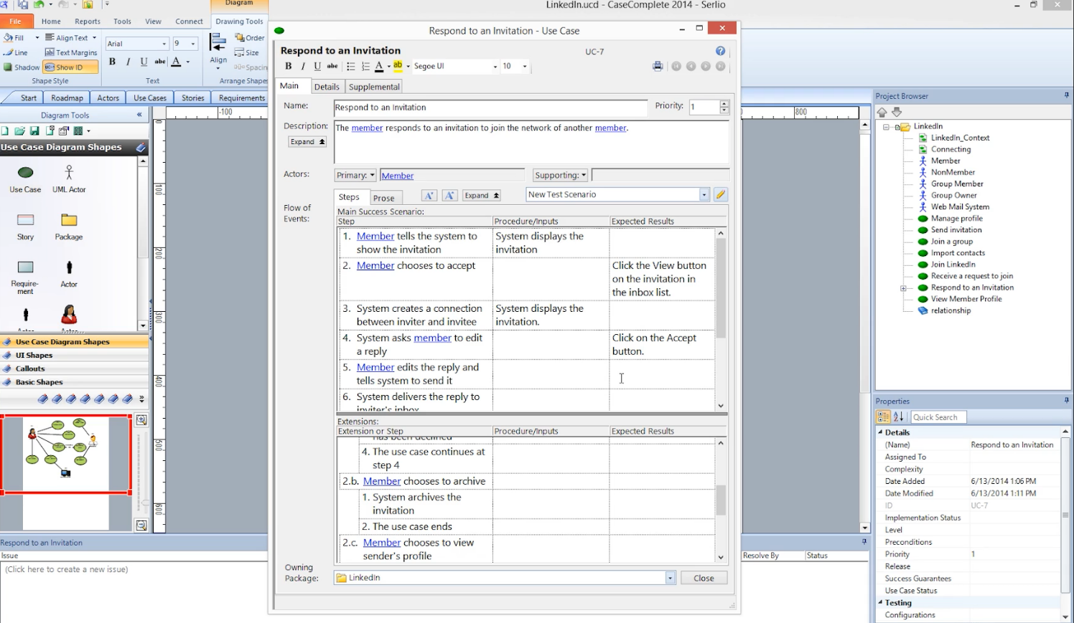

Create use case and describing the scenario of respond to invitation send in linden and see the flow of steps.

2] planning

Different tools used in planning, there is diagrams tools that used to represent system structure and components, the control flow of process. And also using project management tools that calculate cost and effort also scheduling.

Tool example: ORBIT

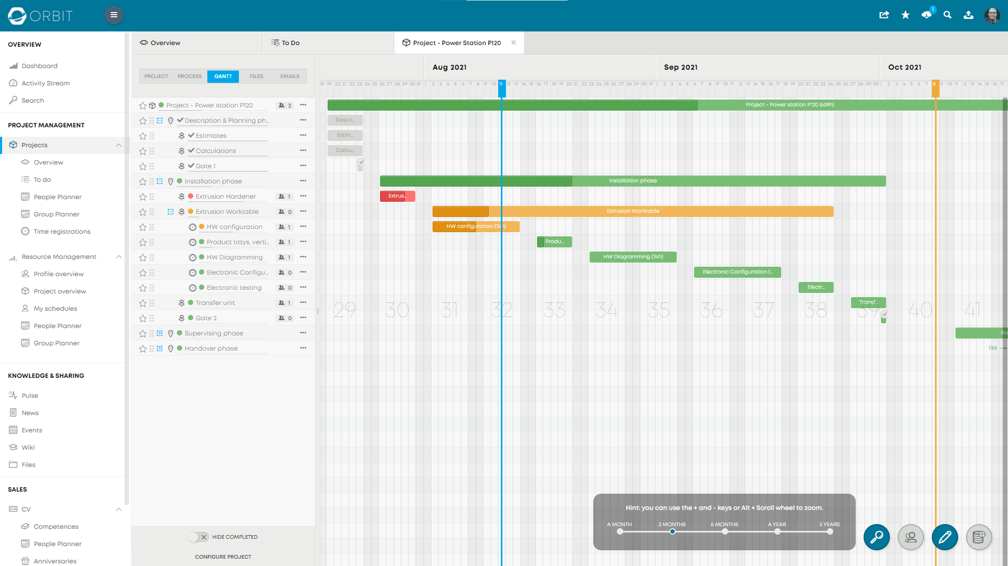

Planning time and management for building power station.

3] design

That include the design of database also UI interface and architecture design.

Tool: SQL server management studio

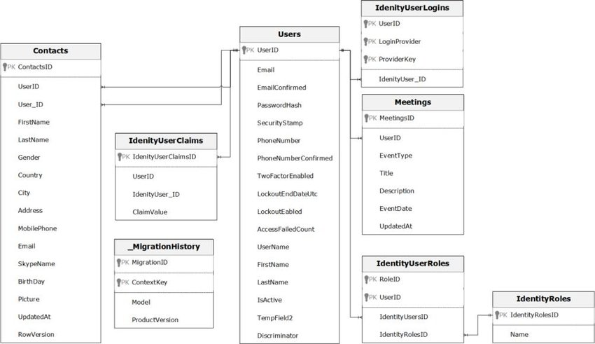

4] development:

Include all IDE that used in programming and writing the code

Tool: VS code (Visual Studio Code)

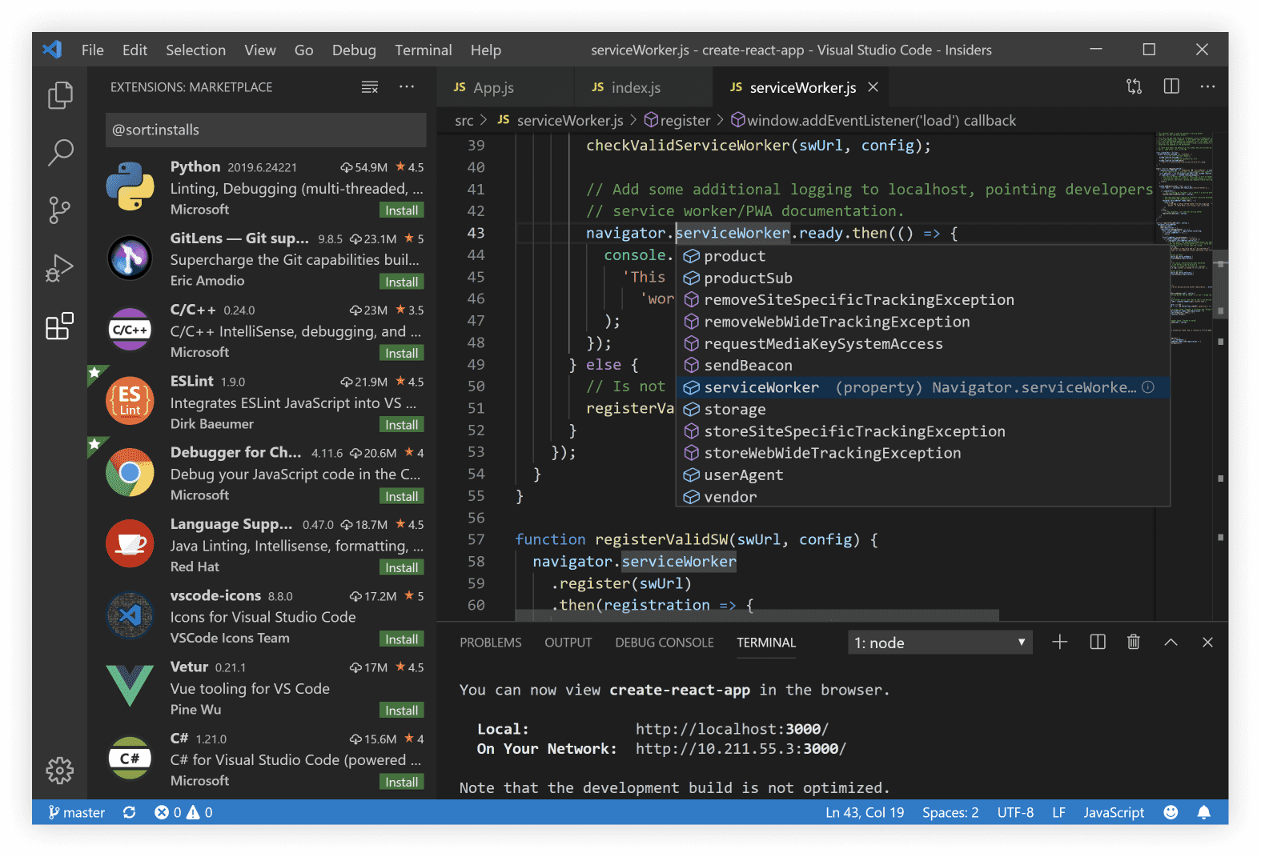

5] testing

It is used to test that the code does the job according to requirements and how code perform

Tool: Testrail

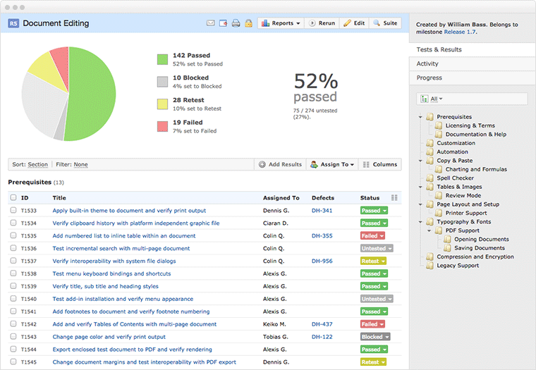

7] Maintenance

Tools used in maintain used for keep tracking the bugs and code changes that might occur after productions and errors reporting

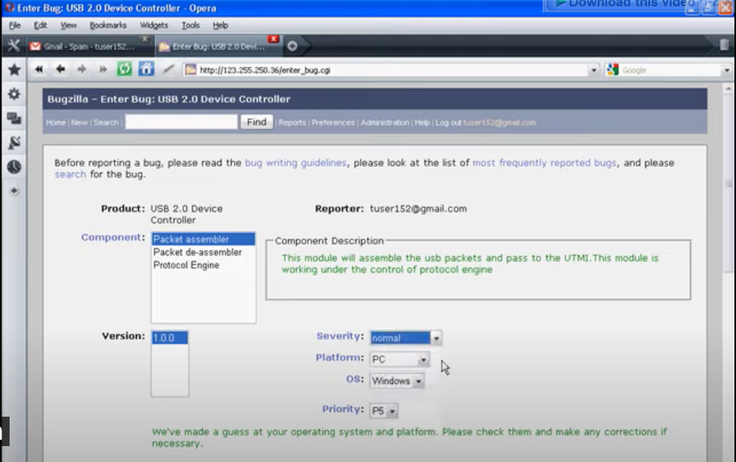

8] documentation:

Documentation tools used to generate documents for users or other developers describing system, its function, the requirements, the plan and literally everything

Tool: Doxygen

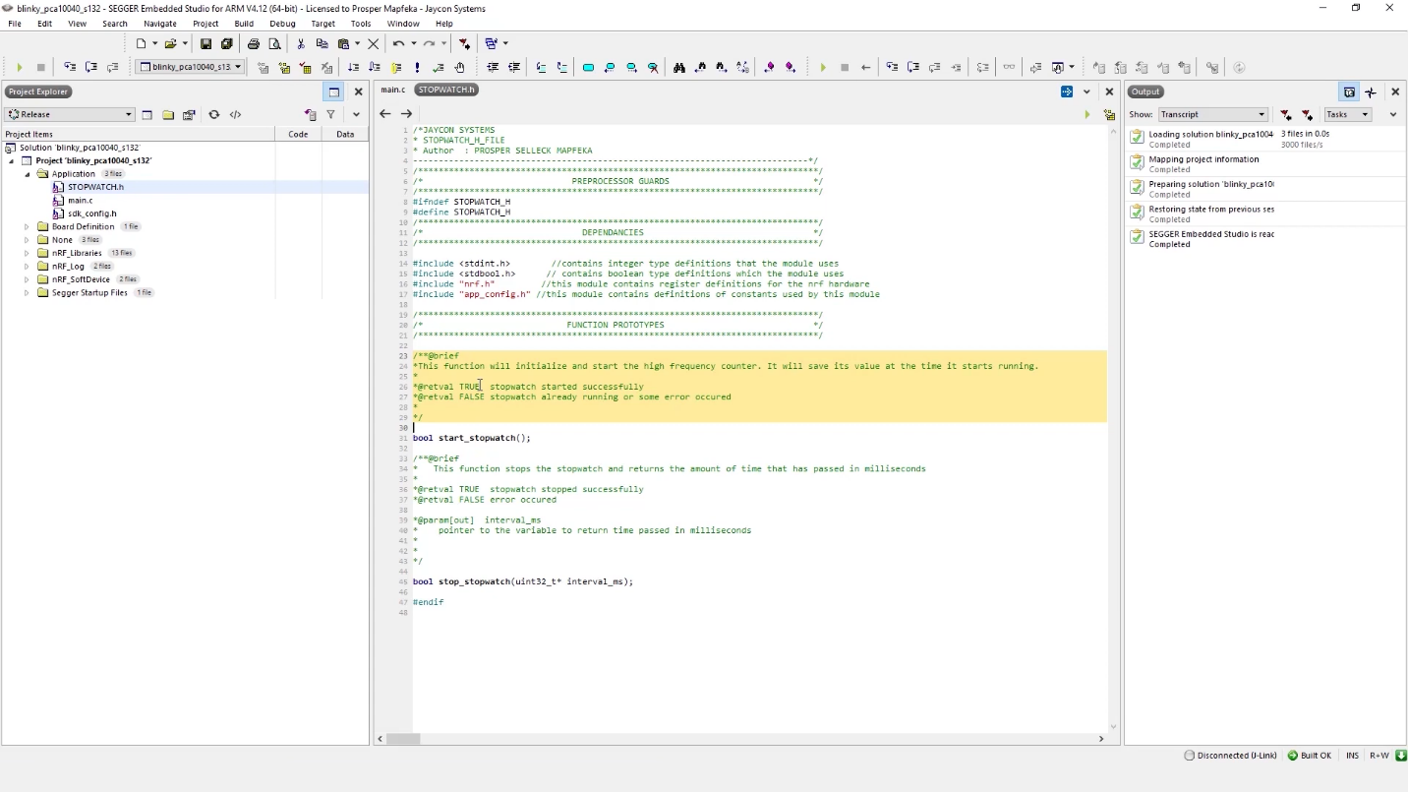

Solved example:

The ERD diagram created by Orcale for database design (hospital management system) focus on tracking the data of patients and their health history to access their information easily and keep it save also their surgeries, x-rays, examination and treatment to help to improve patient’s health care and help doctors to study cases as professionals to improve medical field on them researches.

